Nama : Rizki Nur Fauzi

NIM :18090054

Kelas : 5B

**PRAKTIKUM 5**

1. Source Code

Autoload.php => application / config.php

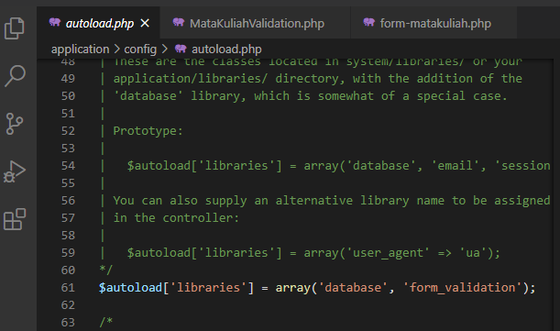

MatakuliahValidation.php => application / controller

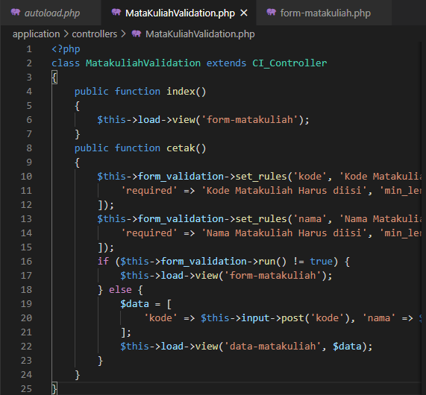

form-matakuliah.php => application / views

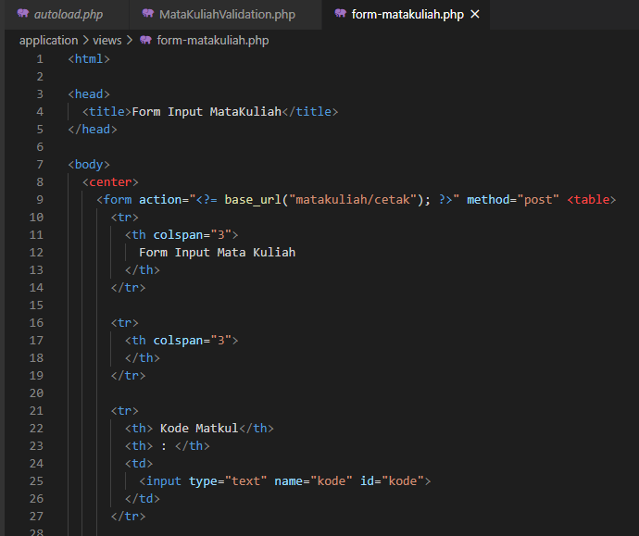

1. URL

http://localhost/pustaka_rizki/index.php/MatakuliahValidation

1. Capture Hasil

